

Gender-Based Violence (GBV)

Prevention Programming

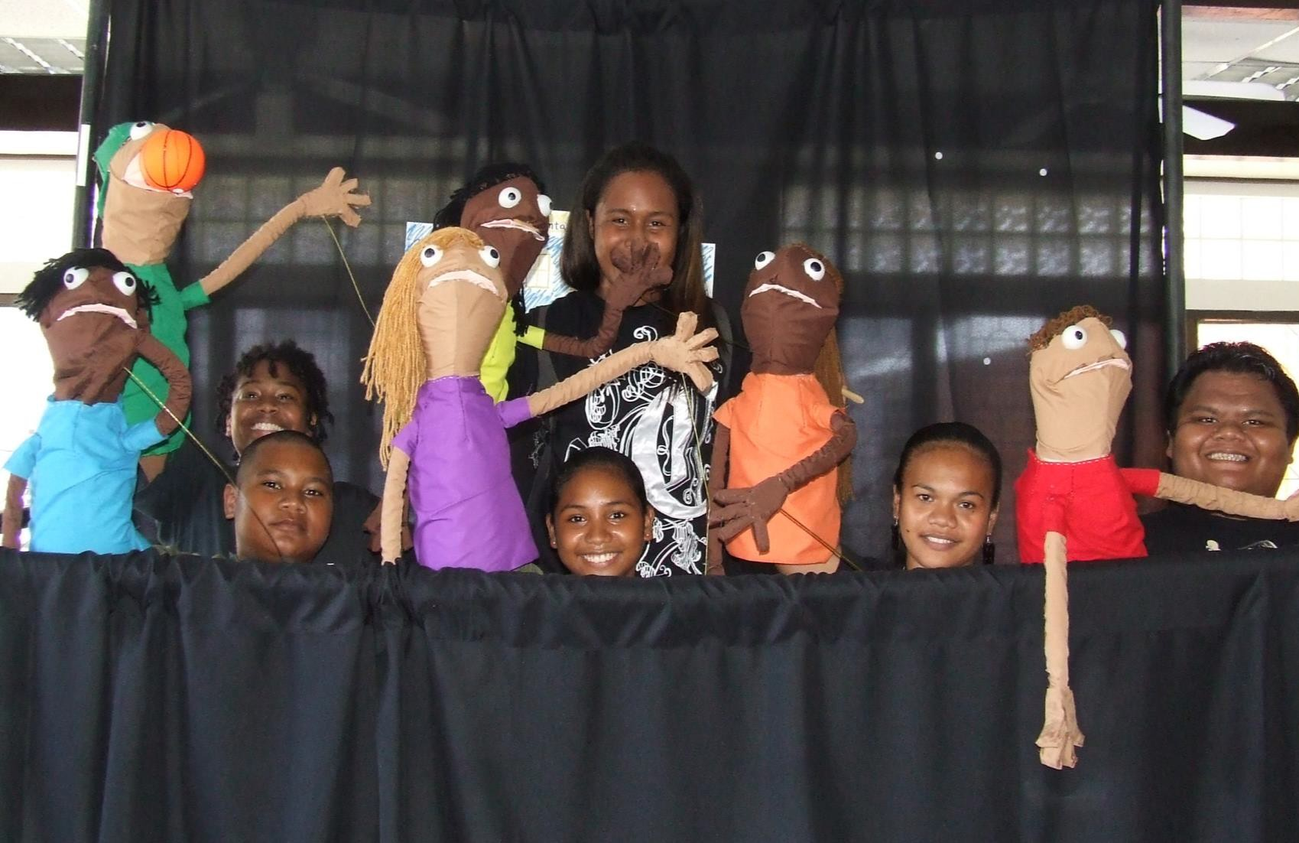A Guide for Peace Corps Volunteers

**Gender-Based Violence (GBV) Prevention**

**Programming**

A Guide for Peace Corps Volunteers

Office of Overseas Programming and Training Support May 2019

Publication No. M0132

Paul D. Coverdell Peace Corps Headquarters 1111 20th Street NW, Washington, DC 20526

**Table of Contents**

Why Address Gender-Based Violence Prevention? 1

Best Practices in GBV Prevention Programming 2

Key Messages 2

What You Can Do 2

What You Cannot Do 3

Critical Consideration for Engaging Communities 3

Peace Corps Aspirational Programming Resources 4

Aspirational Programming Resources from External Organizations 6

**Why Address Gender-Based Violence**

**Prevention?**

As Volunteers, you may witness or come across instances of actions typically known as gender-based violence (GBV), in your schools, host-families, workplaces, and broader communities. These might include, but are not limited to, sexual harassment, coercion and/or assault, domestic and intimate-partner violence, and school- related gender-based violence, including bullying or other acts of violence perpetrated by teachers. You may be angry and confused by what you are seeing, and feel the urgent need to act, to do *something* to confront the perpetrator and assist the person you feel is being hurt. Those feelings and instincts are valid and natural – in fact, many Volunteers have experienced similar feelings in the context of their service.

But what exactly should you do when you witness such incidents? This brief is meant to support you in understanding what actions you can take, and which you should not pursue. It focuses on promoting GBV prevention and building trusting relationships with community members as the two areas that you as a Volunteer are best positioned take on. It also highlights the critical role and significant impact small actions can have in the long-term, and outlines actions you should not do – for your safety and the safety of others around you. It also gives examples of those small actions that serve to support healthy, safe, and enabling environments, for men as well as women and specific programmatic activities that support GBV prevention.

The approaches and considerations regarding GBV prevention are most relevant for Volunteers already working with counterparts on engaging communities in dialogue. They are also helpful for posts looking to support the integration of GBV prevention messaging in their existing activities. While this brief is only intended to support violence prevention activities, it is important to recognize that participants in dialogues may bring up personal experiences with gender-based violence. Please refer to MS 271 and MS 861 for guidance around reporting of incidents of violence. Also consult with safety and security officers regarding protocols for supporting and ensuring the safety of Volunteers who witness or hear of such incidents. Additionally, only those who have been trained in facilitating such conversations and responding appropriately to issues that may be raised should take on such activities.

**Best Practices in GBV Prevention**

**Programming**

The following best practices are based on global evidence from GBV prevention programming. They are important considerations for anyone wanting to support dialogues with community members around gender- based violence.

* **Always** work on GBV prevention programming with a trusted counterpart, community member, or ally and have a counterpart or community member take the lead in dialogues and discussions.
* **Start with building** relationships and trust – this is critical for supporting transformation of norms.
* **Understand** the specific context and cultural issues; don’t make assumptions about women’s and men’s experiences.
* **Focus** on a positive, asset-based approach with individuals and communities.
* **Emphasize** the “drivers” and underlying causes of GBV. It is rooted in gender inequality, gender norms and power imbalances. The most effective prevention efforts focus therefore on building agency and life skills, for both boys *and* girls, men and women.
* **Recognize** that challenging social and community-level gender norms brings possible risks and consequences. Highlight, with their permission, examples of individuals who have successfully “stepped outside” of those norms, and how individuals and communities can support those allies. Keep in mind the need to protect their privacy and safety.
* **Ensure** that you have created an emotionally and physically safe space for everyone participating in a discussion around GBV prevention. See the Creating Safe Spaces brief.

# Key Messages

By focusing on building trusting relationships and working with counterparts and community members to create safe spaces for dialogue, you are contributing to creating an enabling environment. **You are making a difference!** In fact, the evidence shows that without those critical stages occurring, long-term sustainable change will not take place – the transformational effects will simply ***not*** be sustained. You may not see much change in two years, but know that you are making a real impact.

# What You Can Do

There are many important ways you can make a contribution. Some may seem small, but can have a huge impact. In fact, you are probably already doing many of these actions and addressing the issue in powerful ways, through your interactions and work with youth and community members. This might be in camps and clubs, in schools, and through other activities that emphasize social and emotional learning, healthy relationships, respect, equality, and self-esteem. These actions may not lead to immediate transformation, but lay the foundation for long-lasting results. By focusing on the underlying causes, these kinds of activities often have a longer-term impact on preventing the kind of violence you are seeing. You are planting the critical seeds for change, even if

you yourself aren’t able to witness your actions grow. Here are some actions you can take:

* Lend an ear! Remember that having someone listen and “be there” has been identified as the number one factor that people cite in being able to make their own decision related to how to react to violence in their lives.
* Integrate GBV prevention messaging and information in existing activities.
* Identify resources in the community, have a list of such resources ready to provide as referrals, and support linkages with these referrals in lieu of intervening directly.
* Work with a counterpart or trusted community member to engage other community members in respectful dialogue around the benefits of healthy, non-violent relationships and communities.
* Work with a community counterpart to provide aspirational programming that focuses on building agency and life skills and creating a supportive, enabling environment for girls and boys, women and men. See the aspirational programming resources included below for ideas.
* Choose to do nothing. You should not feel compelled or obliged to act or work in this space.

# What You Cannot Do

There are a number of reasons why you should not take direct action or intervene. We know it may be difficult to hear that you should not personally take direct action to address a situation, but your personal safety is Peace Corps’ top priority. Taking action such as standing up to the offender or calling the police may put you in harm’s way, lead to unintended negative consequences – including putting the very person you are trying to protect and assist in greater harm – and cause unintended consequences for the person’s family, friends, classmates, coworkers, or other members of the community. For your safety and the safety of others, you should avoid:

* Putting yourself or any others in danger – your safety is Peace Corps’ top priority.
* Intervening directly in witnessed or suspected cases, including reporting any misconduct to the police or community members before consulting with Peace Corps staff, or taking a visible lead in assisting someone to leave a violent situation, especially when they are not ready.
* Engage in GBV programming without a community counterpart, without having community resource information on hand, or without the knowledge of Peace Corps staff.



**Before taking any action, you should always:**

* Make sure to discuss any contemplated actions with post staff (PMs, SSMs, DPTs, CDs or other staff) in advance
* Consider any potential unintended negative consequences of any actions taken

•

•

Assess whether the intervention may increase violence or result in harm

Ensure that any actions taken would not result in the revictimization of survivors

* Minimize harm to women, girls, staff working with survivors, **and** other vulnerable persons

# Critical Consideration for Engaging Communities

If you are considering working with a counterpart to engage community members in dialogue, it is important to create a safe space for these discussions. Start by taking the time to build trusting, supportive environments where people feel comfortable sharing concerns, experiences, and questions before engaging in sensitive conversations. The brief on [*Creating Safe Spaces for Sensitive Conversations*](https://pclive.peacecorps.gov/pclive/index.php/library/general-subjects/diversity/item/1348-creating-safe-spaces-for-sensitive-conversations-m0134)outlines what a safe space is, what it looks and feels like, and how one can be created. Please review it before beginning any facilitated conversations with community members.

**Peace Corps Aspirational Programming**

**Resources**

[**Engaging Men and Boys around**](https://pclive.peacecorps.gov/pclive/index.php/library/general-subjects/diversity/item/1325-engaging-men-and-boys-activities-and-considerations) **Positive Masculinities (M0133):** [https://pclive.peacecorps.gov/pclive/index.php/library/general-subjects/diversity/item/1349-engaging-men-and-](https://pclive.peacecorps.gov/pclive/index.php/library/general-subjects/diversity/item/1349-engaging-men-and-boys-around-positive-masculinities-m0133) [boys-around-positive-masculinities-m0133](https://pclive.peacecorps.gov/pclive/index.php/library/general-subjects/diversity/item/1349-engaging-men-and-boys-around-positive-masculinities-m0133)

This toolkit supports efforts to engage men and boys around the sensitive topic of masculinity. It outlines 24 activities to create a safe space and facilitate discussion around positive masculine norms. These are divided into six themes, including communication and relationships, fatherhood, men’s health, and violence prevention. It also includes tips and considerations for ensuring effective, respectful facilitation of group activities.

*Recommended sessions:*

1. Effective Communication
2. Healthy and Unhealthy Relationships
3. Expressing my Emotions
4. What Do I Do When I Am Angry?
5. What is Violence?
6. Violence Clothesline
7. The Violence Around Me
8. From Violence to Respect in Intimate Relationships

**Creating Safe Spaces for Sensitive Discussions (M0134)** [https://pclive.peacecorps.gov/pclive/index.php/library/general-subjects/diversity/item/1348-creating-safe-spaces-](https://pclive.peacecorps.gov/pclive/index.php/library/general-subjects/diversity/item/1348-creating-safe-spaces-for-sensitive-conversations-m0134) [for-sensitive-conversations-m0134](https://pclive.peacecorps.gov/pclive/index.php/library/general-subjects/diversity/item/1348-creating-safe-spaces-for-sensitive-conversations-m0134)

One of the most critical considerations for engaging communities around sensitive topics such as gender-based violence or harmful norms is creating a safe space for these discussions. It is important to take time to build trusting, supportive environments where people feel welcome and comfortable sharing concerns, experiences, and questions without fear of judgment. This involves creating physically as well as emotionally safe spaces. This brief outlines what a safe space is, what it looks and feels like, and how one can be meaningfully created.

[**Peace Corps Youth Mentoring Workbook (M0131):**](https://pclive.peacecorps.gov/pclive/index.php/library/general-subjects/children-youth/item/1210-youth-mentoring-workbook-m0127)[https://pclive.peacecorps.gov/pclive/index.php/library/general-subjects/children-youth/item/1210-youth-](https://pclive.peacecorps.gov/pclive/index.php/library/general-subjects/children-youth/item/1210-youth-mentoring-workbook-m0127) [mentoring-workbook-m0127](https://pclive.peacecorps.gov/pclive/index.php/library/general-subjects/children-youth/item/1210-youth-mentoring-workbook-m0127)

This workbook can be used by PCVs and counterparts to foster mentoring relationships with youth, individually and in small groups. Many PCVs mentor youth informally, and this workbook helps structure those relationships with fun, low-resource activities organized in three phases of mentoring: fostering relationships, setting goals, and planning for the future. Mentoring builds critical life skills and agency for girls as well as boys.

*Recommended sessions:*

1. Interests and Hobbies
2. Vision Board
3. Social Spider Mapping
4. Homework Time
5. My Personal Values
6. Planning for the Future

[**Peace Corps Youth Livelihoods Mentoring Workbook (M0128)**](https://pclive.peacecorps.gov/pclive/index.php/library/general-subjects/children-youth/item/1309-youth-livelihoods-mentoring-workbook-m0128)**:** [https://pclive.peacecorps.gov/pclive/index.php/library/general-subjects/children-youth/item/1309-youth-](https://pclive.peacecorps.gov/pclive/index.php/library/general-subjects/children-youth/item/1309-youth-livelihoods-mentoring-workbook-m0128) [livelihoods-mentoring-workbook-m0128](https://pclive.peacecorps.gov/pclive/index.php/library/general-subjects/children-youth/item/1309-youth-livelihoods-mentoring-workbook-m0128)

This workbook is designed for Volunteers and counterparts to use when mentoring youth in building livelihood skills. It outlines a series of fun, adaptable, low-resource activities that foster the development of 12 core skills – focusing on life skills, employability, and entrepreneurship – which prepare youth to identify and communicate their strengths and make decisions related to their goals, ultimately achieving productive livelihoods and contributing to their families and communities.

[**Peace Corps Health and HIV and Life Skills Manual (M0063)**](https://pclive.peacecorps.gov/pclive/index.php/pclive-resources/resource-library/62-m0063-life-skills-manual/file)**:** <https://pclive.peacecorps.gov/pclive/index.php/pclive-resources/resource-library/62-m0063-life-skills-manual/file> This manual outlines a comprehensive behavior change approach that focuses on the development of critical life skills such as communication, decision making, thinking, managing emotions, assertiveness, self-esteem building, peer pressure, and relationship skills. It integrates interactive activities, role plays, games, and group discussions to developing agency among girls and boys, women and men.

*Recommended sessions:*

1. Communication
2. Goal Identification: The Road of Life
3. Passive, Assertive, Aggressive Communication
4. Alcohol and Substance Abuse
5. Peer Pressure
6. Making Good Decisions

**Social and Emotional Learning (SEL) and Mindfulness Curricula (forthcoming)**

**Aspirational Programming Resources from**

**External Organizations**

The following are a select list of aspirational programming resources with an evidence base behind them that Volunteers might find helpful when thinking of activity ideas.1

## Go Girls! Community-Based Life Skills for Girls

<https://www.k4health.org/toolkits/go-girls/go-girls>

Go Girls! offers a safe and fun learning experience that supports girls in building agency and the critical life skills that support them in leading happy, productive, and healthy lives, including staying in or returning to school and protecting themselves from HIV/AIDS. Go Girls! uses a social-ecological, “whole community” approach,

recognizing that girl’s and women’s vulnerability are influenced by a system of socio-cultural relationships. Interventions engage communities, leaders, teachers, parents, and guardians as well as adolescents.

*Recommended sessions:*

1. Speak Up! Communicating With Others
2. Making Good Decisions
3. Healthy Friendships
4. How to Communicate with a Partner
5. Preventing Unwanted Advances
6. Planning My Goal

## Building Assets

[http://www.popcouncil.org/research/building-assets-toolkit-developing-positive-benchmarks-for-adolescent-](http://www.popcouncil.org/research/building-assets-toolkit-developing-positive-benchmarks-for-adolescent-girls) [girls](http://www.popcouncil.org/research/building-assets-toolkit-developing-positive-benchmarks-for-adolescent-girls)

This toolkit outlines an asset-building approach for designing programs to support girls and young women. The approach uses asset cards to engage stakeholders at all levels in identifying their unique strengths and assets – human, social, economic, and cognitive – as the foundation for meaningful programming that resonates with their priorities and addresses their unique challenges.

## Girls Health

<https://www.girlshealth.gov/relationships/index.html>

This website offers tips and considerations for building strong, healthy relationships, aimed at and using language that is intended to resonate with adolescent girls and boys. It covers areas including forming healthy relationships, dating, working out problems in relationships, making friends, getting along with family, and connecting to community.

## Stepping Stones

\\dcna_cifs.peacecorps.gov\agency folders\@Agency_All\Let Girls Learn Program\Programming and Training\Resources\Stepping Stones\S6211-KM28318052410220.pdf

Stepping Stones is a training package that focuses on sexual and reproductive health, HIV, gender norms, communication, and relationship skills. The materials were developed out of the need to address the vulnerability of young people, girls and women in particular, related to decision making and sexual health. The materials have been adapted for use in numerous contexts across the globe, and can be used by facilitators and community members to organize workshops for women and men of all ages.

1 Peace Corps does not specifically endorse the work of any external organizations.