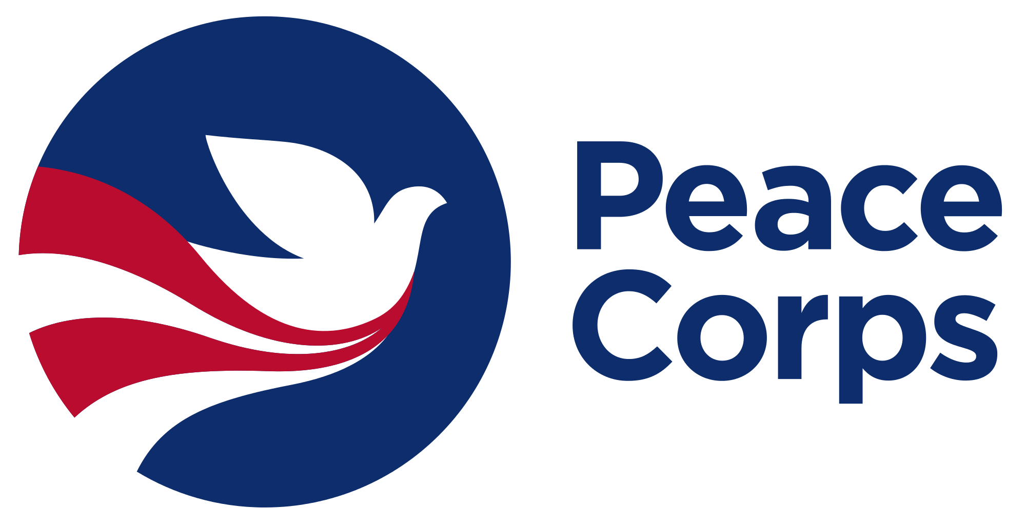
Application for
Peace Corps Volunteer
2020

Please fill out the application form in ENGLISH and send the form to the following email address: pcv.mk@peacecorps.gov

Program Area:
Peace Corps provides Volunteers in three program areas. Please indicate which program area you are applying for (Choose only 1): | ☐ Community Development Program  ☐ English Education Program (TEFL)  ☐ Inclusive Education Program (Special Needs)

Partner Background:
Organization/School’s Full Name in English:
Organization/School’s Full Name in Macedonian/Albanian:
Organization/School Director
Director’s English Level: | ☐ Fluent ☐ Good ☐ Basic ☐ None
Address:
Town/Village:
Organization/School type: | Organization:  ☐ Government  ☐ NGO/CBO  ☐ Center for Persons with Special Needs | School:  ☐ Kindergarten  ☐ Primary  ☐ Secondary  ☐ University
Phone Number:
E-mail
Website:
Has this organization/school hosted a PCV in the past? | ☐ Yes – NAME of PCV(s): ☐ No

All Peace Corps Volunteers must work closely with another staff member who is doing similar work. The purpose of this is so that there can be direct skills transfer between the Peace Corps Volunteer and the staff member. The staff member is also expected to support the Volunteer in their adjustment to their new work place and community. The primary staff member that a Volunteer works with is called a counterpart. Please answer the questions below regarding the counterpart that you will assign to the Peace Corps Volunteer.

Counterpart & Supervisor Contact Information
Name and Title of the Counterpart:
Phone:
E-mail:
English Level: | ☐ Fluent ☐ Good ☐ Basic ☐ None
Previously worked with PCV: | ☐ Yes – NAME of PCV(s): ☐ No
Reason for being selected to be the Counterpart:

Name and Title of the PCV Supervisor:
Phone:
E-mail:
English Level: | ☐ Fluent ☐ Good ☐ Basic ☐ None

Other Colleagues who will work with the PCV
(if any):
Phone:
E-mail:
English Level: | ☐ Fluent ☐ Good ☐ Basic ☐ None

Partnership with Peace Corps Volunteer:
In 4-6 sentences, please provide a brief explanation why are you interested to work with a Peace Corps Volunteer.

Click here to enter text.

Complete this page if applying for a Community Development Peace Corps Volunteer
ORGANIZATION | (if school, skip this section.)
Number of Employees:
Number of local Volunteers:
Working Hours:
Organization’s Mission and Goals
(for local government, note which department will be involved in the collaboration with the Volunteer)
Funding Sources:

Describe Current Programs/Projects:
What ongoing services, programs does your organization have?

Click here to enter text.

In 4-6 sentences, describe the current problems and challenges of your organization.

Click here to enter text.

What is your organizational vision for addressing these challenges/ issues next two years?

Click here to enter text.

Needs Assessment: Community Development Program
Please select from the skill areas below those area(s) in which your organization would like to collaborate with a Peace Corps Volunteer and build its capacity over the next two years.
☐ Community needs assessment  ☐ Building strategic partnerships and networks  ☐ Program design, management and evaluation  ☐ Organizational development  ☐ Training in life skills for youth | ☐ Co-organize youth clubs and youth camps  ☐ Co-organize community engagement activities (such as awareness raising events)  ☐ Volunteering activities  ☐ Other:

Complete this page if applying for an English Education (TEFL) Peace Corps Volunteer
SCHOOL | (if organization, skip this section.)
Number of students:
Number of English teachers:
Satellite schools:
Languages of instruction:

Describe Current Programs/Projects:
Describe the current projects that the school is implementing

Click here to enter text.

What English language activities does the school have outside the classroom (clubs, debate clubs, language contests and competitions etc.)?

Click here to enter text.

List the current resources that the school has (For example: English resource room, Career Centers, Library, Multi Media Room, Sports Hall, Smart board, projector, scanner, printer, laminator etc).

Click here to enter text.

Needs Assessment: English Education Program (TEFL)
Please select from the skill areas below those area(s) in which your organization would like to collaborate with a Peace Corps Volunteer and build its capacity over the next two years.

☐ Differentiated teaching  ☐ Classroom management  ☐ Student-centered methodologies  ☐ Resource development  ☐ Other: | ☐ Co-organize English youth clubs and youth camps  ☐ Co-organize community engagement activities (such as awareness raising events)  ☐ Volunteering activities  ☐ Other:

Complete this page if applying for an Inclusive Education (Special Needs) Volunteer
SCHOOL | (if organization, skip this section.)
Number of students:
Number of students with special needs:
Number of teachers working with students with special needs:
Number of Special Education Teachers:
ORGANIZATION | (if school, skip this section.)
Number of Employees:
Number of local Volunteers:
Number of beneficiaries:
Organization’s Mission and Goals

Describe Current Programs/Projects:
What ongoing services, programs does your organization/school have?

Click here to enter text.

What challenges have your organization/school faced in providing inclusive education for students with special needs?

Click here to enter text.

What organization/school’s vision for addressing the challenges described above?

Click here to enter text.

List the current resources that your organization/school has (For example: Sensory Rooms, Diagnosis/Assessment tools, Career Centers, Library, Multi Media Room, Dedicated Pull-out Classroom, etc).

Click here to enter text.

Needs Assessment: Inclusive Education Program (Special Needs)
Please select from the skill areas below those area(s) in which your organization would like to collaborate with a Peace Corps Volunteer and build its capacity over the next two years.

☐ Differentiated teaching  ☐ Classroom management  ☐ Development of individual educational and lesson plans for students with special needs  ☐ Behavior management for students with special needs  ☐ Working with parents of students with special needs  ☐ Teacher training for inclusive education | ☐ Development of life skills programs  ☐ Development of vocational programs  ☐ Co-organize community engagement activities (such as awareness raising events)  ☐ Other:

All Peace Corps Volunteers are expected to live in the community of their assignment, and to stay at least six months with a home stay family who will support the Volunteer with their language learning and community integration.
It is the responsibility of the applying organization to identify viable host families for the Volunteer they are applying for.
In addition, Peace Corps Volunteers are encouraged to engage and support additional organizations and community development efforts in their communities.

Housing Options:
Please provide three options for Host Families from your community that are willing to host a PCV.

Option 1:
Name and surname:
Telephone:
Address: .

Option 2:
Name and surname:
Telephone:
Address:

Option 3:
Name and surname:
Telephone:
Address:

Community Assessment:
Please list organizations/ institutions/ informal groups in the community that PCV can collaborate with.

Click here to enter text.

Date: Date
Place: Place.
Person who filled out the application form: Name

Please share any additional information and references (brochures, booklets, publications, etc) that will assist Peace Corps in assessing your request for a Volunteer.

