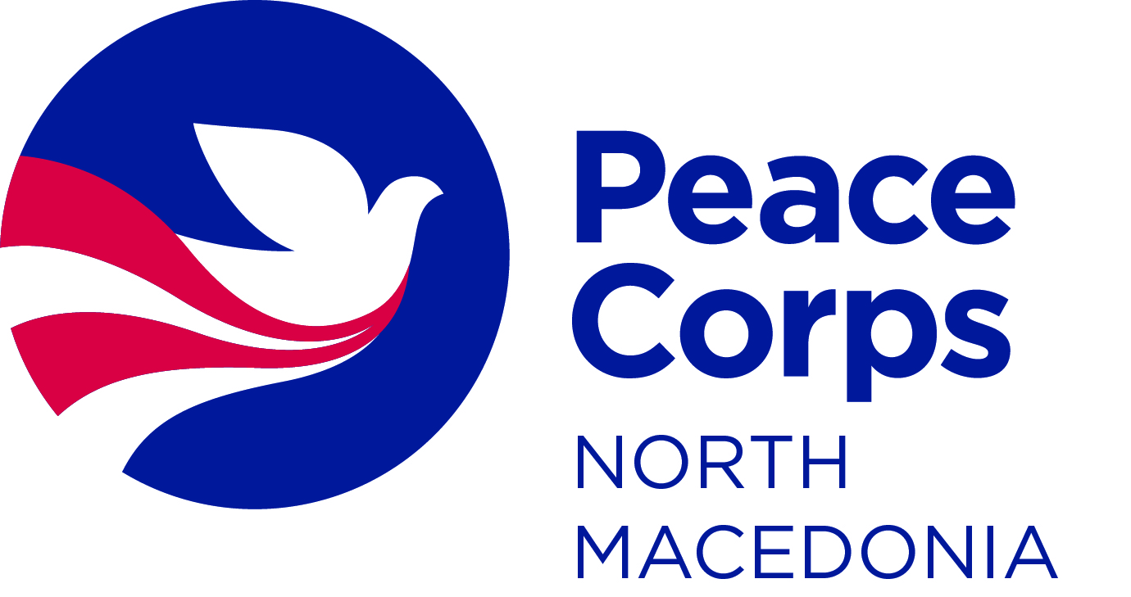

**VOLUNTEER REQUEST FORM**

**Please fill out the application form in ENGLISH and send the form to the following email address:** [**mk-pcv@peacecorps.gov**](mailto:mk-pcv@peacecorps.gov)

Note: This application is valid for two years.

Peace Corps' Role in North Macedonia:

To contribute to the social, economic, and human development of people in North Macedonia through working with collaborating agencies. Peace Corps Volunteers (PCVs) live and work in communities to promote world peace and friendship by partnering to advance shared development goals and through cross-cultural exchange. This allows the people of North Macedonia to understand American culture better and allows the PCVs to strengthen their understanding and appreciation of the culture in North Macedonia. Volunteers collaborate on locally prioritized projects in the areas of Community Development and English Education.

**Peace Corps provides the following to PCVs:**

* Pre- and in-service training events throughout their service;
* Supervision and support throughout their service in cross-cultural, technical, safety, health and well-being;
* Housing expenses and monthly living allowance (includes allowance for meals, transportation, and other incidental costs.);
* Medical care.

**Agencies, organizations, and institutions provide the following to Volunteers:**

|  |
| --- |
| The following list of requirements is the responsibility of the hosting institution to provide each Volunteer placed at the site. Please tick the specific resources and/or facilities that your agency/organization can provide to the PCV:  **Supervisor**: is responsible for assisting the PCV with work orientation, cultural immersion, technical and on-going support.  **Counterpart**: to work with the PCV and to participate in a mutual transfer of skills and knowledge.  **Housing**: appropriate housing options based on Peace Corps’ defined housing standards  (**Note:** While Peace Corps will cover the housing expenses, the hosting institution is responsible for providing appropriate housing options which will be inspected and approved by Peace Corps Staff).  **Workspace**: a dedicated workspace for the Volunteer.  **Additional Support** (office equipment, materials, transportation). |

|  |  |
| --- | --- |
| **PROGRAM AREA** | |
| Peace Corps provides Volunteers in two program areas. Please indicate which program area you are applying for (*choose only 1*): | Community Development Program  English Education Program  Inclusive Education Program |

|  |  |  |
| --- | --- | --- |
| **PARTNER BACKGROUND** | | |
| Organization/School’s Full Legal Name in English: |  | |
| Organization/School’s Full Legal Name in Macedonian/Albanian: |  | |
| Head of the Organization/School Director: |  | |
| Director’s English Level: | Fluent  Good  Basic  None | |
| Address: |  | |
| Town/Village: |  | |
| Phone Number: |  | |
| E-mail |  | |
| Website: |  | |
| Organization/School type: | Organization:  Government  NGO/CBO  Center for Persons with Special Needs | School:  Kindergarten  Primary  Secondary  University |
| Has this organization/school hosted a PCV in the past? | Yes – Name of PCV(s): Type here. Years hosted: Type here.  No | |
| Is any of the employees in your organization related to a Peace Corps staff member? | Yes  No | |

**Note:** All Peace Corps Volunteers must work closely with another staff member who is doing similar work. The purpose of this is so that there can be direct skills transfer between the Peace Corps Volunteer and the staff member. The staff member is also expected to support the Volunteer in their adjustment to their new workplace and community. The primary staff member that a Volunteer works with is called a counterpart. Please answer the questions below regarding the counterpart that you will assign to the Peace Corps Volunteer.

|  |  |
| --- | --- |
| **COUNTERPART & SUPERVISOR CONTACT INFORMATION** | |
| Name and Title of the Counterpart: | Type here. |
| Phone: | Type here. |
| E-mail: | Type here. |
| English Level: | Fluent  Good  Basic  None |
| Previously worked with PCV: | Yes – NAME of PCV(s):  No |
| Reason for being selected to be the Counterpart: | Type here. |

|  |  |
| --- | --- |
| Name and Title of the PCV Supervisor: | Type here. |
| Phone: | Type here. |
| E-mail: | Type here. |
| English Level: | Fluent  Good  Basic  None |

|  |  |
| --- | --- |
| Other Colleagues who will work with the PCV (if any): | Type here. |
| Phone: | Type here. |
| E-mail: | Type here. |
| English Level: | Fluent  Good  Basic  None |

|  |
| --- |
| **PARTNERSHIP WITH PEACE CORPS VOLUNTEER** |
| In 4-6 sentences, please provide a brief explanation why are you interested to work with a Peace Corps Volunteer.  Type here. |

To continue to Community Development, click here.

To continue to English Education, click here.

To continue to Inclusive Education, click here.

### Complete this page if applying for a Community Development Peace Corps Volunteer

|  |  |
| --- | --- |
| **ORGANIZATION** | **(if school, skip this section.)** |
| Number of employees: | Type here. |
| Number of local Volunteers: | Type here. |
| Working hours: | Type here. |
| Organization’s mission and goals (for local government, note which department will be involved in the collaboration with the Volunteer) | Type here. |
| Funding sources: | Type here. |

|  |
| --- |
| **CURRENT PROGRAMS/PROJECTS** |
| What ongoing services, programs does your organization have?  Type here. |
| In 4-6 sentences, describe the current problems and challenges of your organization.  Type here. |
| What is your organizational vision for addressing these challenges/ issues next two years?  Type here. |

|  |  |
| --- | --- |
| **NEEDS ASSESMENT: COMMUNITY DEVELOPMENT PROGRAM** | |
| **Please select from the skill areas below those area(s) in which your organization would like to collaborate with a Peace Corps Volunteer and build its capacity over the next two years.** | |
| Community needs assessment  Building strategic partnerships and networks  Program design, management and evaluation  Organizational development  Training in life skills for youth | Co-organize youth clubs and youth camps  Co-organizecommunity engagement activities (such as awareness raising events)  Volunteering activities  Other: Type here. |

### Complete this page if applying for an English Education (TEFL) Peace Corps Volunteer

|  |  |
| --- | --- |
| **SCHOOL** | **(if organization, skip this section.)** |
| Number of students: | Type here. |
| Number of English teachers: | Type here. |
| Satellite schools: | Type here. |
| Languages of instruction: | Type here. |

|  |
| --- |
| **CURRENT PROGRAMS/PROJECTS** |
| Describe the current projects that the school is implementing  Type here. |
| What English language activities does the school have outside the classroom (clubs, debate clubs, language contests and competitions etc.)?  Type here. |
| List the current resources that the school has (For example: English resource room, career centers, library, multimedia room, sports hall, smart board, projector, scanner, printer, laminator etc).  Type here. |

|  |  |
| --- | --- |
| **NEEDS ASSESMENT: ENGLISH EDUCATION PROGRAM (TEFL)** | |
| **Please select from the skill areas below those area(s) in which your organization would like to collaborate with a Peace Corps Volunteer and build its capacity over the next two years.** | |
| Assist with different levels in the classroom  Classroom management  Student-centered methodologies  Resource development | Co-organize English youth clubs and youth camps  Assist with library improvement in the school  Teach English to the teachers in the school  Other: Type here. |

### Complete this page if applying for an Inclusive Education (Special Needs) Volunteer

|  |  |
| --- | --- |
| **SCHOOL** | **(if organization, skip this section.)** |
| Number of students: | Type here. |
| Number of students with special needs: | Type here. |
| Number of teachers working with students with special needs: | Type here. |
| Number of special education teachers: | Type here. |
| **ORGANIZATION** | **(if school, skip this section.)** |
| Number of employees: | Type here. |
| Number of local volunteers: | Type here. |
| Number of beneficiaries: | Type here. |
| Organization’s mission and goals | Type here. |

|  |
| --- |
| **CURRENT PROGRAMS/PROJECTS** |
| What ongoing services and or programs does your organization/school have?  Type here. |
| What challenges have your organization/school faced in providing inclusive education for students with special needs?  Type here. |
| What organization/school’s vision for addressing the challenges described above?  Type here. |
| List the current resources that your organization/school has (For example: Sensory Rooms, Diagnosis/Assessment tools, Career Centers, Library, Multi Media Room, Dedicated Pull-out Classroom, etc).  Type here. |

|  |  |
| --- | --- |
| **NEEDS ASSESMENT: INCLUSIVE EDUCATION PROGRAM (SPECIAL NEEDS)** | |
| **Please select from the skill areas below those area(s) in which your organization would like to collaborate with a Peace Corps Volunteer and build its capacity over the next two years.** | |
| Assist with different levels in the classroom  Classroom management  Development of individual educational and lesson plans for students with special needs  Behavior management for students with special needs  Working with parents of students with special needs  Teacher training for inclusive education | Development of life skills programs  Development of vocational programs  Co-organizecommunity engagement activities (such as awareness raising events)  Other: Type here. |

**Note:** All Peace Corps Volunteers are expected to live in the community of their assignment, and to stay**Note:** All Peace Corps Volunteers are expected to live in the community of their assignment, and to stay at least four months with a host family who will support the Volunteer with their language learning and community integration.

It is the responsibility of the applying organization to identify viable host families for the Volunteer they are applying for.

In addition, currently serving Peace Corps Volunteers are encouraged to engage and support additional organizations and community development efforts in their communities.

|  |
| --- |
| **HOUSING OPTIONS** |
| **Please provide three options for host families from your community that are willing to host a PCV.**  **Option 1:**  **Name and surname**: Type here.  **Telephone**: Type here.  **Address**: Type here.  **Option 2:**  **Name and surname**: Type here.  **Telephone**: Type here.  **Address**: Type here.  **Option 3:**  **Name and surname**: Type here.  **Telephone**: Type here.  **Address**: Type here.  **Is any of the listed options related to a Peace Corps staff member?**  Yes  No |

|  |
| --- |
| **COMMUNITY ASSESMENT:** |
| **Please list organizations/ institutions/ informal groups in the community that the PCV can collaborate with.**  Type here. |

**NOTE: WE WISH TO REMIND YOU THAT PEACE CORPS POLICY SPECIFIES THE FOLLOWING:**

1. No Peace Corps Volunteer should deprive a citizen of North Macedonia of a job.

2. A Peace Corps Volunteer addresses basic needs at the grassroots level.

3. A Peace Corps Volunteer’s assignment builds local capacity.

4. A Peace Corps Volunteer should have people from North Macedonia as work partners associated with all assignments.

**Date of application:** Type here.

**Place:** Type here.

**Name and last name of the person who filled out the application form:** Type here.

**Please share any additional information and references (brochures, booklets, publications, etc.) that will assist Peace Corps North Macedonia in assessing your request for a Volunteer.**